**DevOps Internship Assignment**

**Log Analysis and Monitoring Script**

Tasks:

Log File Monitoring:

Write a script that continuously monitors a specified log file for new entries.

Use tail or similar commands to track and display new log entries in real time.

Implement a mechanism to stop the monitoring loop (e.g., using a signal like Ctrl+C).

Log Analysis:

Enhance the script to perform basic analysis on log entries:

Count occurrences of specific keywords or patterns (e.g., error messages, HTTP status

codes).

Generate summary reports (e.g., top error message)

Solution:

Prerequisites: Python to be installed

Dependencies: None

Testing: You can test the script by following the steps below and observing its behavior when monitoring a sample log file. Additionally, you can create different log files with various entries to test different scenarios and see how the script analyzes and reports on the log data.

1. Create a EC2 instance

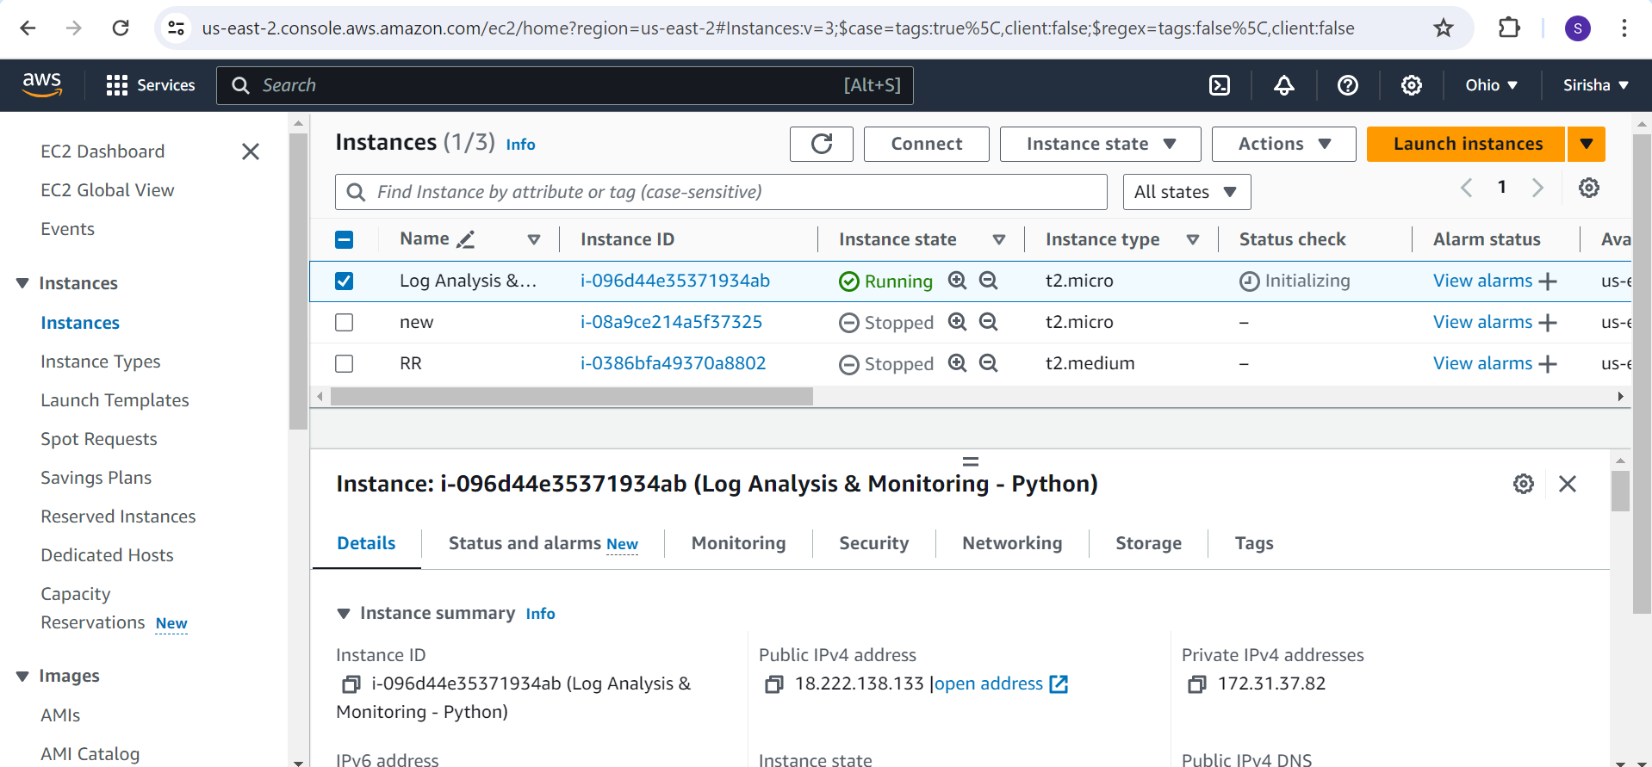

1. Install Python

sudo yum check-update

sudo yum install python3

python3 –version

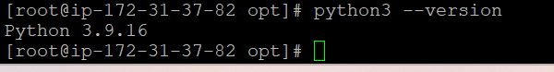

1. Create vi log-monitor.py

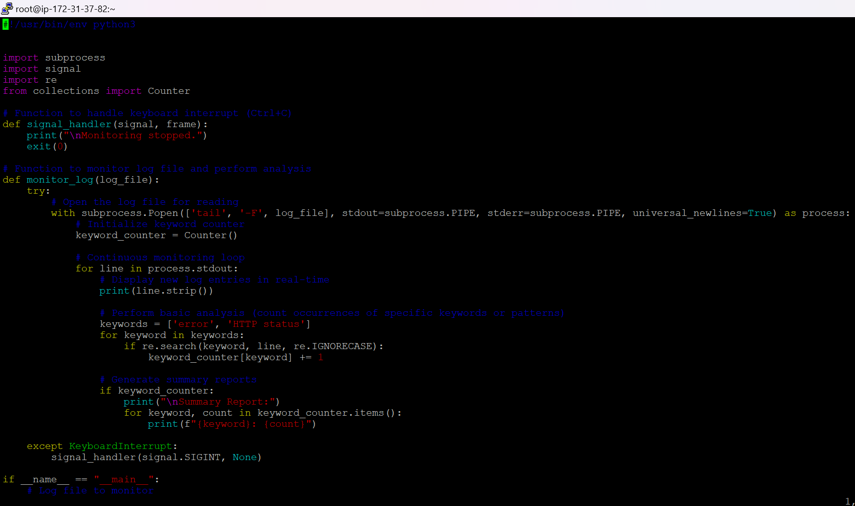

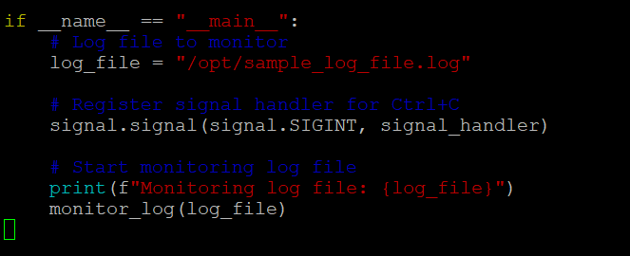

1. Give permissions chmod +X log-monitor.py



1. Create a sample-log-file.log in sample path. Let say /opt/sample-log-file.log

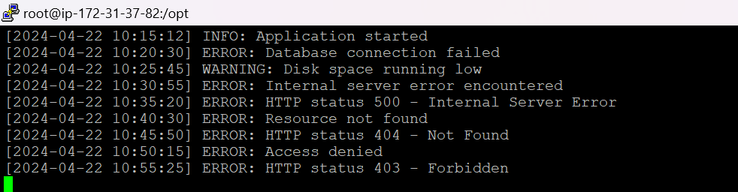

1. Provide the path in log-monitor.py script

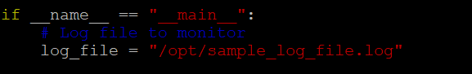

1. Execute ./log-monitor.py

1. Observe the Output

